
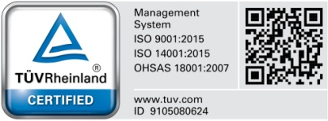
Hanna Instruments SRL
Romania, Salaj, Nusfalau, Str. Hanna, Nr. 1
Tel.: +40/260/607700; Fax: +40/260/607739
Document No. MR-

Material Requisition

Section1 : Made by From Production Line no./department :

Today
Planning Reference :

Hanna Code & Qty
Note

Materials requested :

No. | Code | Description | CAS | Q.ty Required | Real Qty | Lot | Location | Specified Location

Section 1 will be filled up by production line leader.

Section2 : Processed by

Approval | Name | Signature | Department | Name | Signature
Department Manager/ Requester |  |  | Warehouse
General Manager/ Delegate |  |  | Planning Completed
Planning Analyze

Section 2 will be filled up by warehouse and planning responsible

